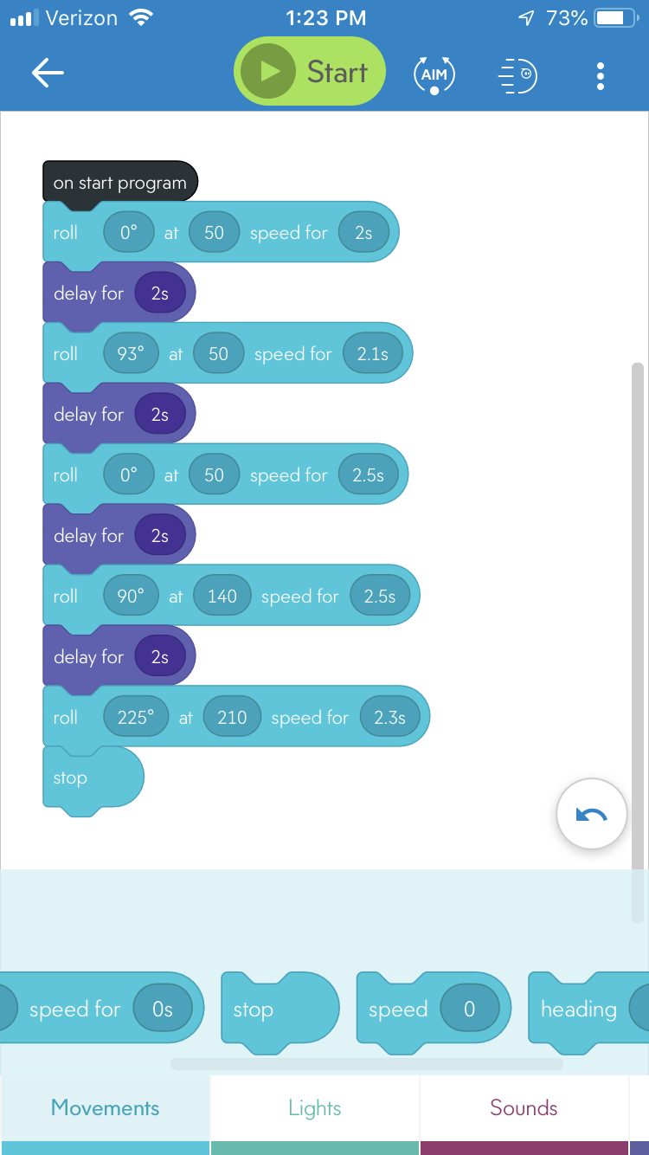

|  |  |  |  |  |
| --- | --- | --- | --- | --- |
| Reason for Test Case | Test Date | Expected Output | Observed Output | Pass/Fail |
| Go from 70 to 60 | 12/2 | Go within the line for the turn to complete the sprint | Overshot a little Just need to decrease the speed by a tad bit and should be fine | Fail |
| Go from 60 to 50 on first speed | 12/2 | Pass from conclucion of test 1 | It worked for the test conducted | Pass |
| Go from 70 to 60 | 12/2 | Decrease the speed to not overshoot | Overshot the marker again | Fail |
| Go from the turn of 90 degrees to 93 for more maneuverability | 12/2 | To follow in the line perfectly and complete it | Completed just a little off at the end will adjust speed and time | Pass |
| 40 to 45 for the 3rd turn | 12/2 | Too completely clear the 3rd turn and complete the entire sprint | A little short since the turn was adjusted | Fail |
| 45 to 50 for the 3rd turn | 12/2 | To completely pass the 3rd turn | Perfectly adjusted the speed for the test now needs to fix the last area to decrease the speed and add a stop | Pass |
| Decreased speed from 225 to 210 | 12/2 | To hit all the markers in the triangle and stop | Hits the triangle and all the markers | Pass |